## **Situation Appraisal**

To embed analytics into strategy has to be the challenge that every company that has a data culture is currently pursuing. To develop a long lasting architecture that becomes the DNA of the organization and one that helps in the decision-making process is a task that is worth taking on. R Shiny is not just a beautiful app but is a useful solution ready for production in an enterprise environment and one that goes through a wide range of engineering thresholds.

## **Business Goals**

1. We will develop an app for the top management to aide decision-making and host it on cloud. I will use R and put it through a code review at PullRequest.com and get the Non-Disclosure Agreements signed.
2. We will make use of simulation-driven technologies when we encounter intractable highly complex management problems.
3. I have access to the Stack Overflow Teams workflow which ensures Intellectual Property is protected and encourages a healthy work environment. I use Proton VPN for utmost security.
4. We will deliver unprecedented analytics expertise on complex strategy problems that can deliver ROI-driven quick-to-market solutions that are cost optimal.

## **Case Studies**

1. Strategy recommendation to a client: To think of raising prices may seem disastrous at first but we will not be carrying out such an exercise across the board but will engage in a discriminatory methodology wherein we will target only low performing customers to renegotiate discounts. Likewise, there are likely to be a number of customers who contribute to high Customer Lifetime Value (CLV) levels but are not offered substantial discounts. We will also target these customers to retain and increase their sales share. We will use a game theoretic model to inform our pricing as part of our Industrial Organization strategy. Thus, after analyzing, for instance, negotiated discounts, we will carry out this mode of looking at CLV and discounts for each of the discount types that the firm offers like growth programs, promotions, and inventory rebates. Also, concurrently, we will attack the problem from 2 other directions. Because of our renegotiations with the customers it is likely we will lose a percentage to the competition. We will put in place a growth program to acquire new customers. We will also deploy a loyalty program to increase customer retention rates. This should see us serving a better pool of clientele.
2. Strategy recommendation to a client on complexity, fast moving environment, and managerial choice: Which of the moves adaptation, imitation, or innovation is likely to generate a sustainable competitive advantage especially under a fast moving environment? I use computer simulations to arrive at the optimal mix. Organizational modularity is also taken into account as managers make choices based on previous experiences. This is used to guide appropriate level of investments in firm-level marketing operations using advanced analytics under a Balanced Scorecard approach. The project minimizes cost and maximizes return on marketing campaigns.

## **Deliverables**

* Project to be completed within 60 days of receiving advance payment
* App hosted on [www.shinyapps.io](http://www.shinyapps.io)
* 2 revisions
* End-of-the-project PowerPoint presentation
* Standard Operating Procedure (SOP) document
* Technical documentation
* All other collateral
* 1-2 day training program

## **Customer Support**

* Tech support - Q&A Chat, Zoom, and Phone
* Maintenance - Concurrently on cloud without user interruption. Provide patches for bugs via quick Turn Around Time (TAT).

## **Pricing**

|  |
| --- |
| **Advanced Analytics embedded in MBB Strategy $75,000** |
| We will gather data, formulate a model based on apriori marketing, financial, or manufacturing theory and estimate the model parameters. We will either increase revenue or reduce costs. |
| We will use 81 corporate strategies identified by BCG as our base. We will identify our environment as one of the 5 archetypal ones and zone in on our strategy formulation. We will use advanced analytics to inform our strategy. In doing so we will build out a case for competitive advantage with improved long term profitability. |
| We will develop an R shiny app with aesthetics and user friendliness that will incorporate all the advanced analytics and strategy formulation. We will also carry out all the software engineering steps to build a robust decision support system that will be hosted on cloud for it to be handed over. |

|  |
| --- |
| **Advanced Analytics embedded in Wharton Strategy Research $150,000** |
| We will gather data, formulate a model based on apriori marketing, financial, or manufacturing theory and estimate the model parameters. We will either increase revenue or reduce costs. |
| We will use the behavioral theory of the firm advocated firmly in Wharton strategy research to formulate our strategy. We will extend Wharton strategy research. In particular, we will use computer simulations to chalk out a roadmap. We will use advanced analytics to inform our strategy. In doing so we will build out a case for competitive advantage with improved long term profitability. |
| We will develop an R shiny app with aesthetics and user friendliness that will incorporate all the advanced analytics and strategy formulation. We will also carry out all the software engineering steps to build a robust decision support system that will be hosted on cloud for it to be handed over. |

## **Requirements**

During the pre-work phase, I will need to understand the broad contours of the problem statement by speaking to:

1. The in-house analytics personnel
2. The end-user decision-maker

You would be taking on external developers for multiple projects every year. I freelance. I am an analytics developer expert. I build decision support systems; lets bake-in at least 2 big ones this year.

## **About Me**

I am an RStudio listed consultant.

I am a part of the GLG Member Council.

I want to be the supplier of choice.

I am an alumnus of the economics postgraduate program housed in the business school at IIM Calcutta (No.1 ranked department in the world by FT 2014).

I was ranked No.2 in the analytics postgraduate program at IIT Bombay.

I am on the mailing list of COIN OR-the definitive computational resource for the operations research community. I am in the process of submitting a production project under the Eclipse License Agreement.

I was in the PhD 1st year Strategy Simulation programme at The University of Texas at Dallas.

## **Next Steps**

The pricing is valid **till 20th May, 2021**. To take advantage of this proposal:

* Accept the proposal as-is.
* Discuss desired changes if any in the Terms and Conditions section of the contract with Prashant Prakash Deshpande (Prashant here on for the purposes of the rest of the document).
* Finalize and sign the contract.

1. Commission the first engagement within 2 weeks of signing the contract with 1-2 weeks of discussion to freeze the type and nature of the project. Alternatively, I am open to working on a small project in pricing strategy to kick-start things and build rapport and relationship and demonstrate earth-shattering value at $1750 (a sample report attached in the Appendix).
2. Submit an advance payment of 50 percent of total project fee when the project is commissioned.
   1. Pre-work begins immediately within 4 business days.
   2. I will schedule a project kick-off meeting subsequently within 2 weeks which is extremely crucial to discuss what success looks like.

## **Terms and Conditions**

Once the project fee is paid in full to me, all collateral will be handed over.

Prashant assumes that any code, scripts, data, and reports provided for inclusion in the development of the app do not have any lien on them.

Prashant retains the right to display graphics and other elements as examples of his work in his portfolio and as content features in other projects.

To accept the proposal as-is, sign off below, scan, and email [decisionapps@protonmail.ch](mailto:decisionapps@protonmail.ch). Subsequently, I will send across the complete proposal and contract with my sign for your records.

Client company name and seal:

|  |  |  |  |  |
| --- | --- | --- | --- | --- |
|  |  |  |  |  |
| [Name], Project Client (The Decision Support System User) |  | [Name], Project Sponsor |  | [Name], Project Manager |

|  |
| --- |
|  |
| Prashant |

APPENDIX

Problem Statement

For a firm producing digital products such as software, the capital costs are sunk. They were used to produce the digital content and cannot be redeployed. There may be premises to rent for the few staff on rolls, fixed costs such as internet access, servers, and website maintenance can be easily expanded if demand rises. Prices in the digital market will reflect what the customers are willing to pay. In line with Hamill and Gilbert (2015), we assume that there are online sellers with subscription plan sales models with no capacity constraints and no fixed costs.

Consumers buy from the first seller they come across if the seller’s asking price is less than or equal to the consumer’s Willingness-To-Pay. Each consumer buys once. Sellers that fail to trade during any time period (or round) leave. Sellers that have traded look at the prices of others and adjust their own prices using undercutting or price reduction or both.

Simulation Solution

Number of industry players: 10 distributed with mean monthly subscription rate of $300 and a standard deviation of $30.

Number of prospective customers: 1000 with mean Willingness-To-Pay of $100 and a standard deviation of $100.

Number of simulation runs: 100.

Pricing Strategy 1: Seller 1 selects a random competitor and compares prices. The higher of the 2 competitors revises the price to that of the lower competitor and undercuts him by 10%.

Pricing Strategy 2: Seller 1 selects a random competitor and compares prices. The higher of the 2 competitors revises the price to that of the lower competitor. The lower priced competitor reduces the price by 10%.

Pricing Strategy 3: Seller 1 selects a random competitor and compares prices. The higher of the 2 competitors revises the price to that of the lower competitor and undercuts him by 10%. The lower priced competitor reduces the price by 10%.

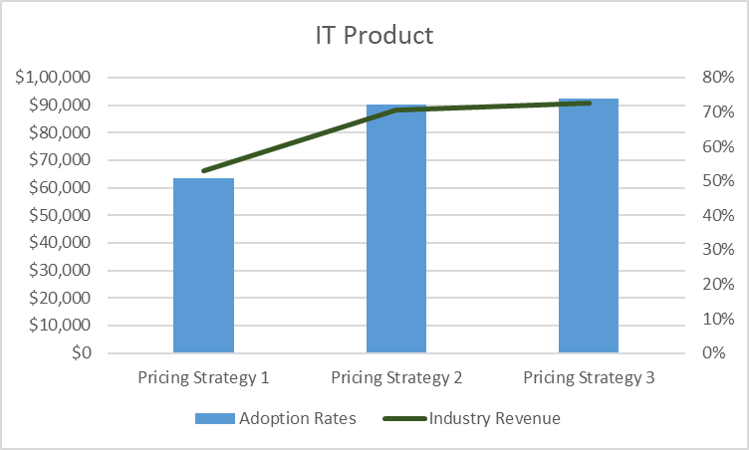

Fig. 1 Optimizing Pricing

Clearly, Pricing Strategy 3 wins it with 74% adoption rate and $90000+ in revenue over 50 rounds of buying and selling activity.

Extension

1. Hamill and Gilbert (2015) show that higher the initial price, the larger the number of sellers that survive for longer. The results illustrate why producers of digital products need to innovate by producing ‘upgrades’ to maintain their profits and sales. The import of such a result is clear whereas actual numbers can easily be run in a customized report.
2. We can also model customer churn through a Markov Chain transition matrix with average industry-wide numbers.
3. We can also make it more realistic by having firms with revenue generation during any one round less than a particular threshold leave.

What I will need

1. Willingness-To-Pay data from customers lost which can be sourced from the sales team.
2. Your list of 9 competitors and their prices - I can do a secondary research and we can collaborate on the findings to match in-house resources.

References

Hamill, L., Gilbert, N. (2015). *Agent-based Modelling in Economics*. John Wiley & Sons, Ltd.